EQ3 Large Abdominal Aortic Aneurysm
Stem: A 68 year-old-male is worked up by his PCP for lower GI bleeding and found on colonoscopy to have a mass in the sigmoid colon.
Biopsy showed a T3 adenocarcinoma.
For staging, CT of the chest abdomen and pelvis reveals a 2cm sigmoid mass, no evidence of metastatic disease, and a 6.5 cm infrarenal AAA.

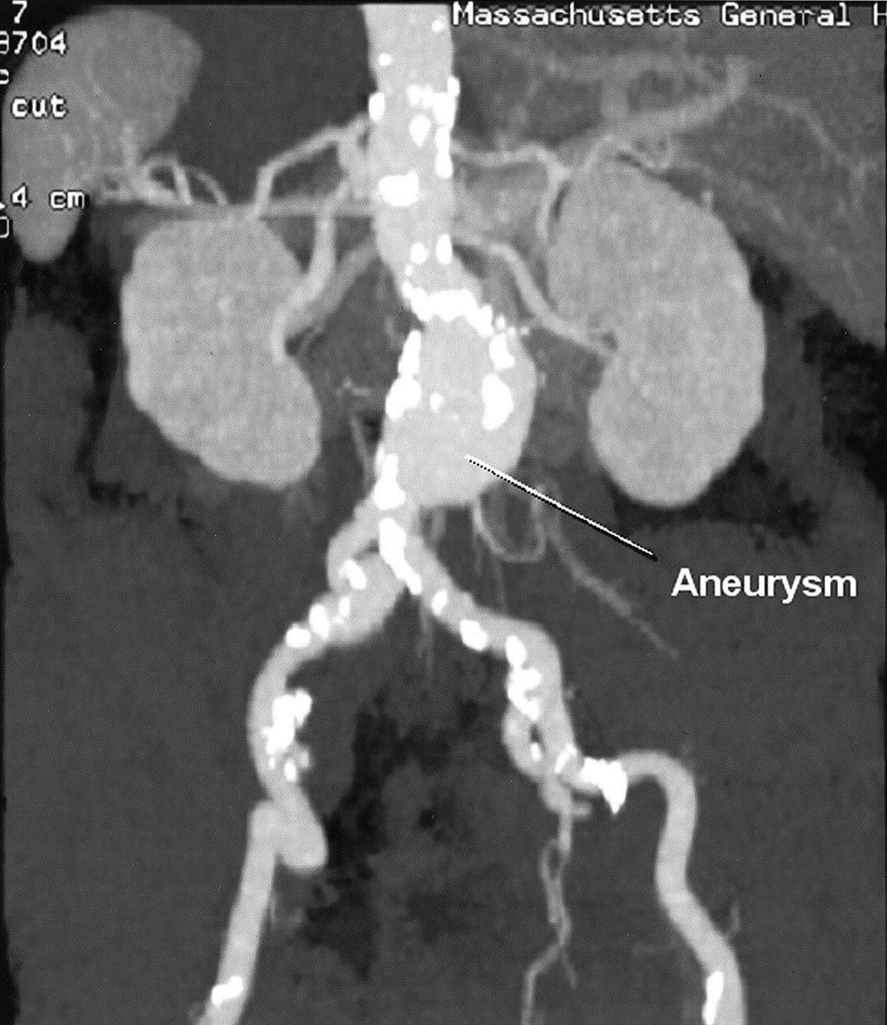
He is referred to your office for management.
PMH: diet-controlled diabetes, and hypertension on lisinopril.
Social Hx: 50 pack-year smoking.
He is vitally normal
Labs : Hb 7.2.

Any Additional Workup or Studies?

- CTA to evaluate AAA anatomy:
Shows 1.7cm infrarenal neck, 2cm neck diameter, 40° neck angle, 1cm femoral artery diameter.

What Would you like to do Now?
- EVAR candidate
- Pre-op optimization
  - Smoking cessation
  - Diabetes and BP control.
  - Monitor anemia optimize with iron and vitamin supplements.
  - Pre-op type and screen
- EVAR first, followed by left hemicolectomy in 2 weeks.

What is the risk of aneurysm rupture after laparotomy for non-vascular cause?

Increased may be due to activation of matrix metalloproteinases. Thus, aneurysm should be addressed.

Scenario continues: The patient is taken to the OR for EVAR, and on post op CT scan 1 week later demonstrates an asymptomatic type 2 endoleak from the IMA. How would you like to proceed, keeping in mind his sigmoid cancer history?
- Proceed with colectomy
- High ligation of the IMA which will resolve the endoleak.

Scenario: A similar patient presents to the ED with abdominal pain and is found to have an obstructing sigmoid mass and a concurrent 5.5 cm AAA. How would you proceed in this case?
- Urgent colectomy for resection of the mass and relief of the obstruction. Strongly consider colostomy or diverting loop ileostomy
- Interval AAA repair either open retroperitoneal or EVAR approach

This patient will need adjuvant chemotherapy, when should he get it?
After AAA repair to minimize risk of AAA rupture

Scenario: The same patient, with an obstructing sigmoid mass but now an 8cm AAA.
- Both the obstruction and the AAA should be dealt with urgently.
- Consider stenting the obstruction as a bridge to colectomy
- AAA repair during this hospitalization
- CT chest abdomen and pelvis during this hospitalization for metastatic workup for colon cancer

